“Key To Your Future”

Project details:
Location: Kaposvár, Hungary
Duration: 10 months
Period: September 2015-July 2016
Volunteers: 16 ( 4 German, 2 English, 1 Estonian, 2 Italian, 2 French, 3 Transylvanian, 2 Spanish)

Location: Kaposvár, Somogy County

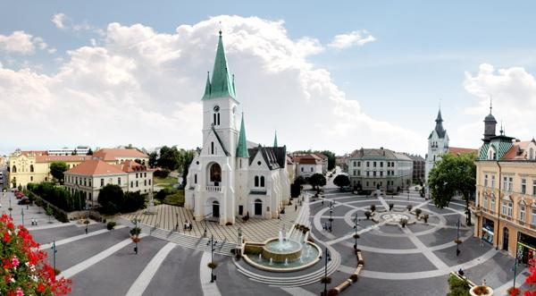

The main square of Kaposvár, the town of 70 000 inhabitans

About Compass Youth Organization:

Compass Egyesület has been established in 2005, and we are working with YIA program since 2006. From that time we hosted more, than 300 foreigner EVS volunteers and sent abroad 43. In Hungary we are the biggest NGO in EVS hosting: right now we host 18 EVS volunteers together in one time. When we have summer camps the number used to rise up to 23. Our main aim to involve the local youth to the local and international activities, to gain their skills and competencies and to
show them a different way of learning: Life Long Learning based on non-formal education. We believe, to develop their own selves, they need to experience what volunteering means and they need to try themselves in different activities. We are bringing them opportunities to travel; in 2013 we have been partners and sent our local groups to 63 youth exchanges, seminars, training courses. We believe, by working at our NGO not only the local student will gain knowledge, but the EVS volunteer as well. We have a key competence specialized program what we are doing with them during their service. Our NGO is well known about the spirit of teamwork, the great example of living together with many different cultures and nations. When someone is applying for an EVS place at Compass needs to commit: he/she is going to join to the biggest and greatest international Family of Hungary.
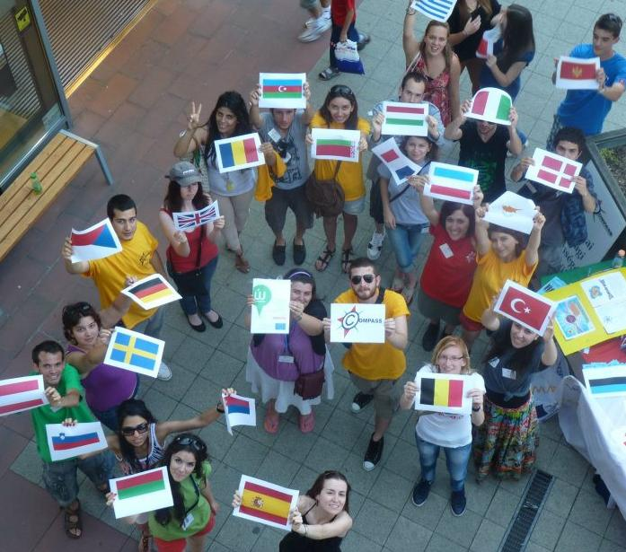

our EVS volunteers promoting EVS in a shopping center

Nowadays we are the most active and successful NGO in the whole country, and we are the only one in our county (Hungary is divided for 19 counties).
We are located in the south-west of Hungary near the Croatian border. The capital Budapest is around 250 km away, and it takes about 3 hours to get there by train or bus. We are very lucky because Lake Balaton, the largest lake in Central Europe, is in our county. The lake is about a 90 minutes drive from Kaposvár.

President: Andrea Eglyné Katona (katonaandrea1@gmail.com)
Coordinators:
Szilvia Waltner-Pécsi (szilvia.waltner@compassegyesulet.hu)
Nikolett Vágner (nikolett.vagner@compassegyesulet.hu)
Nándor Csergő (nandor.csergo@compassegyesulet.hu

About the Project:

The target group of the project is the youth who live in Kaposvár and the surrounding area. The local young people do not have much chance to travel, they are not motivated to learn languages and they do not have international experiences.
Because of this we take the international environment to our city, to the Compass Office! Our EVS volunteers are our tools! We offer the chance for the youth to come to our office and experience an international environment, to improve the language communication, social, cultural, and social skills, organizing free time activities, summer camps, send them abroad for EVS, Youth Exchanges or trainings. We are offering them this possibilities, to extend their chances!

Tasks of the volunteer:

Attendance to Compass Ability Quest later making self sufficient Ability Quests. The most important tasks of the volunteer:

Cultural clubs.

The volunteer have to lead language clubs for youth the age between 6-30 but in some case for elders also. The aim of these clubs is to teach language for the local youngsters, using the methods of the non-formal education. The volunteer has to use/teach her/his own language and English. The volunteer has to teach the participants to communicate in foreign language. They have to prepare for every lessons, choose and discuss about different topics, like sport, culture, movies, history, or anything which is interesting for the participants. The aim of the club is not only teaching the language itself but the volunteer’s national culture.

Background work:

The volunteer has to prepare every week for the following weeks for the language clubs. They have to find theme, photos, movies, games which they can use in the clubs for teaching and practising languages. He has to prepare some written accessories for the Compass Ability Quest, partly documenting the effects of the program.
The tools of the program: team building, sport and role playing games and self development training. During the small group programs the youngsters discover the new knowledge together and share experiences. Through the volunteer they discover a whole new culture.

Language lessons in local secondary schools

The volunteer regularly goes to local secondary schools, to take part in language lessons. This is useful for the local community because they have a chance to hear and learn from a native speaker who lives in the country of the language what they learn. By this they can improve their communication skills in several kind of themes which is connecting to the country where the volunteer came from. We are also doing outreach work in 2 elementary, 9 secondary school, where we promote local and international projects, Erasmus + program.

Take part in popularization of the Erasmus + program

We regularly go to local schools, make presentations, take part in youth events in the city and in the region, make conferences in city hall, county hall, or in different kind of events. In these events one of our task is to popularize the Youth In Action/Erasmus + program, the EVS and our own projects. The volunteer has to take an active part in these events, use their own ideas, presentations, ideas. They have to build up presentations, have a speech in conferences, introductions in the mentioned events.

Summer camp

The volunteer has to lead groups in summer camps. These camps are for Hungarians and also for foreign. For Hungarian groups we make these camps as intensive language course, so the volunteer have to figure out tasks, activities, games, programs, articles, for the youngsters for the participants to make them practise the English language in through activities and to learn it in the real life.

Useful free time activity

The volunteer should provide, or offer possibility for take part in useful free time activity for the local youth depending on the abilities or possibilities of the volunteer. For example involve the youth to sport activities, or art programs or any kind what the volunteer is interested in. We regularly have recycling, CV writing, health prevention, intercultural, art workshops.

Active part of office life

The volunteer has to take active part of the everyday life in the office. Helping in organizing youth programs, dealing with EVS database, give information for local youth about Youth In Action/Erasmus program. Going to unemployment office to hold presentations, info days about opportunities abroad.

Kindergarten project:
We visit local kindergarden to have creative, health prevention, sport activities.

Mother’s shelter:
Which works as temporary home for families, violated women. Our volunteer’s task is to entertain kids, develop mother’s competences with language clubs, computer knowledge and helping them to get back to labor market with CV and motivation letter writing workshops.

Retired Club:
Holding cultural, art, recycling workshops.
Village program:
We regularly visit disadvantaged areas where mostly minority people lives. Holding cultural, sport, gastronomy program for them.

Every month you will write a Monthly Report. You will write about the activities you have done and attach pictures. Then you will see how much you have achieved!

We have a weekly meeting in the office. During these meetings Andrea Katona and the coordinators can talk about any special events or programmes which will happen in the next week. We can also discuss any problems or ideas that we have.

Accommodation, workplace

We expect the volunteer to:

• totally respect of the accommodation provided by the placement and the rules of common life.
• Provide sending and hosting organization with written reports in every month as required.
• Take care conscientiously of the materials and objects that are being provided by the hosting organization (camera, phone, office equipments, furnitures etc) for him/her in order to fullfill the goals and objectives of the project much easier, if not required to pay the equivalent amount of money for each one in part.

• In the accommodation the volunteer has to take care about the cleaning, washing up the dishes, take care of the appointments
• The volunteer has to keep clean the part of the office where he works. After the language clubs he or them has to take away the mess, if there is any, put back the materials (games, cards, papers, pens, etc) what they used in to their place.
• Take seriously her/his commitment to the whole period

• Support the aims and methods of the placement and to carry out conscientiously and to the best of her/his knowledge the tasks related to her service
• Support the aims and methods of the placement and to carry out conscientiously and to the best of her/his knowledge the tasks related to her service
• The volunteer agrees to complete a voluntary service within above named placement.

Work time:

Maximum 35 hours weekly. Daily agenda: 10:00 to 18:00
Free days: two days per every week. (Saturday, Sunday) The work hours are flexible depending on the volunteer’s and the instructor’s needs. If the volunteer has to work on the weekend, then the volunteer gets the free day in another time.
One month the volunteer has two free days! it means that during 12 month the volunteer has 24 days for holiday.

Please remember to bring:
● Some souvenirs from you country e.g flags, postcards and miniature models of famous places would all be brilliant. You can also bring brochures from the tourist office. But also anything else you can find! It would also be very good if you could bring some magazines in your language. If you have folk clothes bring it with you. They might help in your lessons and give people an idea about your culture too.
● Your laptop, if you have one
● A camera and SD card, if you have one
● Towels (but we can give you bedding)
● Photo of your friends, family,
● Your favourite book, pillow in case you get homesick

Check us on facebook:
facebook.com/compass.egyesulet

